Book Borrowing Management System(MVC)

View

* Home
* Tokenvalidation Form
* Book-search
* Book-loan
* Send-reminder

Screen Shot

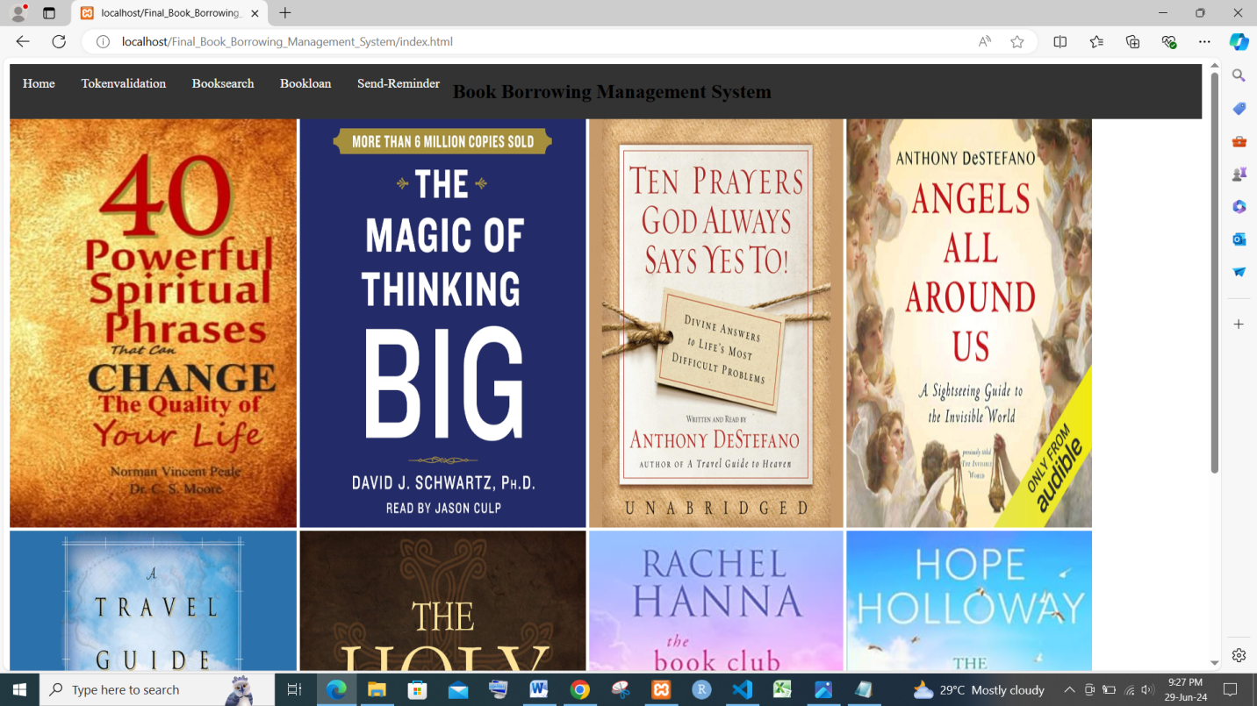

HOME PAGE

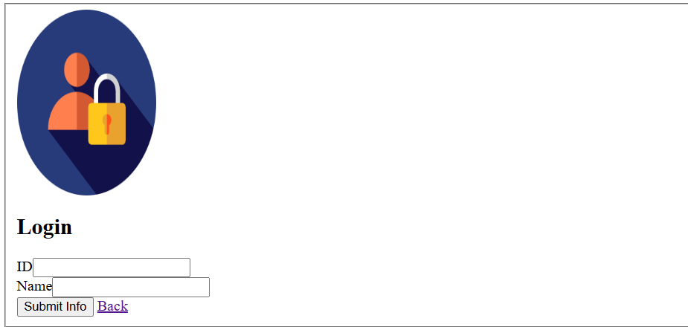

LOGIN FORM

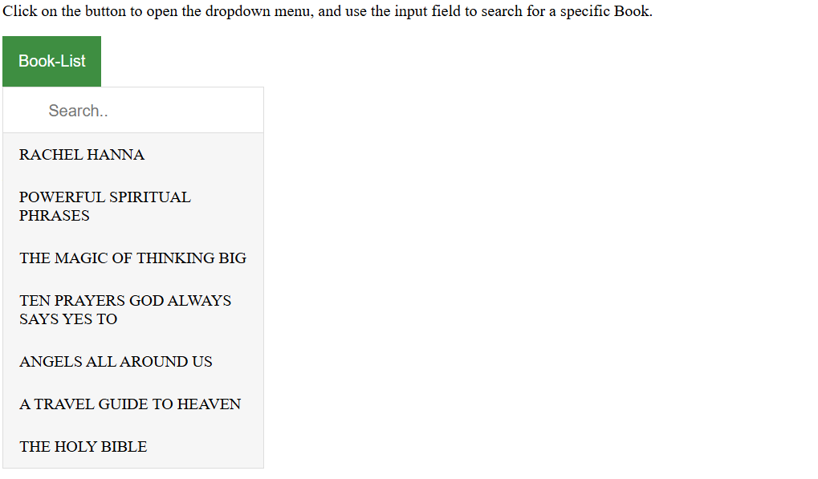

BOOK SEARCH PAGE

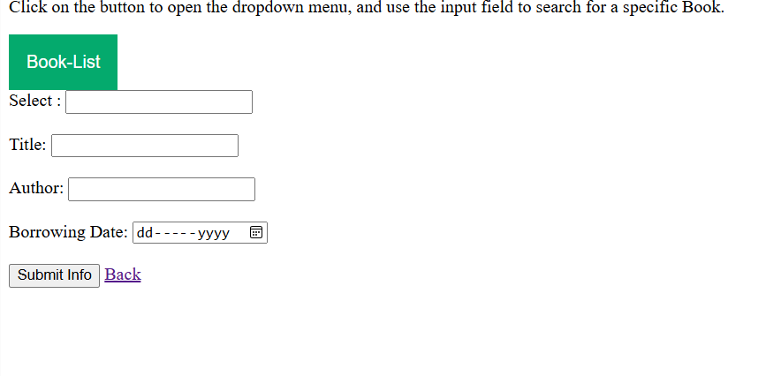

BOOK SELECT PAGE

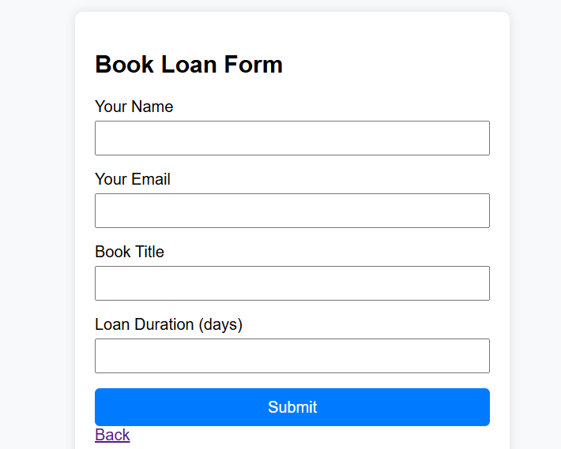

BOOK LOAN PAGE

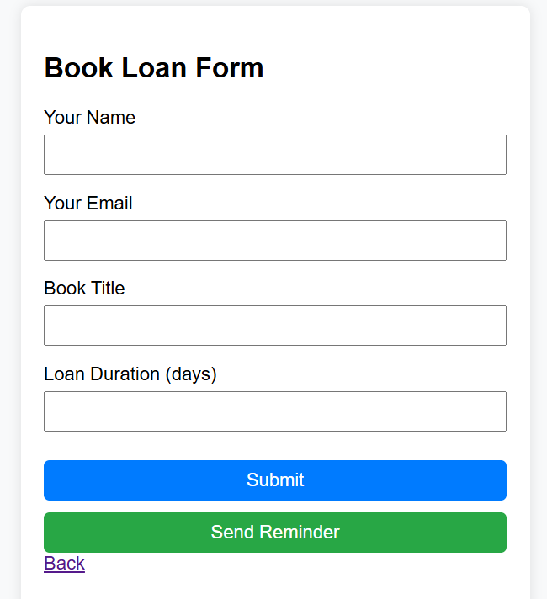

SENDER REMINDER PAGE

Control

tokenvalidation.php

<?php

$id = $_REQUEST['student'];

$name = $_REQUEST['name'];

echo "My id is $id <br/> And My name is {$name}";

session_start();

function checkBorrowing($id, $username) {

    if (isset($_COOKIE['borrow_data'])) {

        $borrowData = json_decode($_COOKIE['borrow_data'], true);

        if ($borrowData['id'] === $id && $borrowData['username'] === $username) {

            $lastBorrowTime = $borrowData['timestamp'];

            $currentTime = time();

            $sevenDaysInSeconds = 7 * 24 * 60 * 60;

            if (($currentTime - $lastBorrowTime) < $sevenDaysInSeconds) {

                return true;

            }

        }

    }

    return false;

}

function setBorrowCookie($id, $username) {

    $borrowData = [

        'id' => $id,

        'username' => $username,

        'timestamp' => time()

    ];

    setcookie('borrow_data', json_encode($borrowData), time() + (7 * 24 * 60 * 60), "/");

}

if ($_SERVER['REQUEST_METHOD'] === 'POST') {

    $id = $_POST['student'];

    $username = $_POST['name'];

    if (empty($id) || empty($username)) {

        $error = "ID and Username are required.";

    } else {

        if (checkBorrowing($id, $username)) {

            $message = "Please wait 7 days before borrowing again with the same ID and username.";

        } else {

            setBorrowCookie($id, $username);

            $message = "You have successfully login!";

        }

    }

}

if (isset($error)) {

    echo "<p style='color: red;'>$error</p>";

}

if (isset($message)) {

    echo "<p style='color: red;'>$message</p>";

}

?>

booksearch.php

<?php

$title = $_REQUEST['title'];

$author = $_REQUEST['author'];

$date = $_REQUEST['date'];

echo " Book title is {$title}<br/> And Author is {$author}<br/>  Borrowing date is {$date} ";

session_start();

function checkBorrowing($id, $username) {

    if (isset($_COOKIE['borrow_data'])) {

        $borrowData = json_decode($_COOKIE['borrow_data'], true);

        if ($borrowData['id'] === $id && $borrowData['username'] === $username) {

            $lastBorrowTime = $borrowData['timestamp'];

            $currentTime = time();

            $sevenDaysInSeconds = 7 * 24 * 60 * 60;

            if (($currentTime - $lastBorrowTime) < $sevenDaysInSeconds) {

                return true;

            }

        }

    }

    return false;

}

function setBorrowCookie($id, $username) {

    $borrowData = [

        'id' => $id,

        'username' => $username,

        'timestamp' => time()

    ];

    setcookie('borrow_data', json_encode($borrowData), time() + (7 * 24 * 60 * 60), "/");

}

if ($_SERVER['REQUEST_METHOD'] === 'POST') {

    $title = $_POST['title'];

    $author = $_POST['author'];

    $date = $_POST['date'];

    if (empty($title) || empty($author) || empty($date)) {

        $error = "ID and Username are required.";

    } else {

        if (checkBorrowing($title, $author,$date)) {

            $message = "Please wait 7 days before borrowing again with the same ID and username.";

        } else {

            setBorrowCookie($title, $author,$date);

            $message = "You have successfully login!";

        }

    }

}

if (isset($error)) {

    echo "<p style='color: red;'>$error</p>";

}

if (isset($message)) {

    echo "<p style='color: red;'>$message</p>";

}

?>

Bookloan.php

<?php

$name = $_REQUEST['name'];

$email = $_REQUEST['email'];

$booktitle = $_REQUEST['bookTitle'];

$loanduration = $_REQUEST['loanDuration'];

echo " Your name is {$name}<br/> Email is {$email}<br/>  Book Title is {$booktitle}<br/>  Book Loan Duration is {$loanduration} ";

session_start();

function checkBorrowing($name, $email,$booktitle,$loanduration) {

    if (isset($_COOKIE['borrow_data'])) {

        $borrowData = json_decode($_COOKIE['borrow_data'], true);

        if ($borrowData['id'] === $id && $borrowData['username'] === $username) {

            $lastBorrowTime = $borrowData['timestamp'];

            $currentTime = time();

            $sevenDaysInSeconds = 7 * 24 * 60 * 60;

            if (($currentTime - $lastBorrowTime) < $sevenDaysInSeconds) {

                return true;

            }

        }

    }

    return false;

}

function setBorrowCookie($id, $username) {

    $borrowData = [

        'id' => $id,

        'username' => $username,

        'timestamp' => time()

    ];

    setcookie('borrow_data', json_encode($borrowData), time() + (7 * 24 * 60 * 60), "/");

}

if ($_SERVER['REQUEST_METHOD'] === 'POST') {

    $name= $_POST['name'];

    $email = $_POST['email'];

    $booktitle = $_POST['bookTitle'];

    $loanduration = $_POST['loanDuration'];

    if (empty($name) || empty($email)|| empty($booktitle)|| empty($loanduration)) {

        $error = "ID and Username are required.";

    } else {

        if (checkBorrowing($name, $email,$booktitle,$loanduration)) {

            $message = "Please wait 7 days before borrowing again with the same ID and username.";

        } else {

            setBorrowCookie($name, $email,$booktitle,$loanduration);

            $message = "You have successfully login!";

        }

    }

}

if (isset($error)) {

    echo "<p style='color: red;'>$error</p>";

}

if (isset($message)) {

    echo "<p style='color: red;'>$message</p>";

}

?>

Bookloan.php

<?php

$name = $_REQUEST['name'];

$email = $_REQUEST['email'];

$booktitle = $_REQUEST['bookTitle'];

$loanduration = $_REQUEST['loanDuration'];

echo " Your name is {$name}<br/> Email is {$email}<br/>  Book Title is {$booktitle}<br/>  Book Loan Duration is {$loanduration} ";

session_start();

function checkBorrowing($name, $email,$booktitle,$loanduration) {

    if (isset($_COOKIE['borrow_data'])) {

        $borrowData = json_decode($_COOKIE['borrow_data'], true);

        if ($borrowData['id'] === $id && $borrowData['username'] === $username) {

            $lastBorrowTime = $borrowData['timestamp'];

            $currentTime = time();

            $sevenDaysInSeconds = 7 * 24 * 60 * 60;

            if (($currentTime - $lastBorrowTime) < $sevenDaysInSeconds) {

                return true;

            }

        }

    }

    return false;

}

function setBorrowCookie($id, $username) {

    $borrowData = [

        'id' => $id,

        'username' => $username,

        'timestamp' => time()

    ];

    setcookie('borrow_data', json_encode($borrowData), time() + (7 * 24 * 60 * 60), "/");

}

if ($_SERVER['REQUEST_METHOD'] === 'POST') {

    $name= $_POST['name'];

    $email = $_POST['email'];

    $booktitle = $_POST['bookTitle'];

    $loanduration = $_POST['loanDuration'];

    if (empty($name) || empty($email)|| empty($booktitle)|| empty($loanduration)) {

        $error = "ID and Username are required.";

    } else {

        if (checkBorrowing($name, $email,$booktitle,$loanduration)) {

            $message = "Please wait 7 days before borrowing again with the same ID and username.";

        } else {

            setBorrowCookie($name, $email,$booktitle,$loanduration);

            $message = "You have successfully login!";

        }

    }

}

if (isset($error)) {

    echo "<p style='color: red;'>$error</p>";

}

if (isset($message)) {

    echo "<p style='color: red;'>$message</p>";

}

?>

Sender reminder.php

<?php

$name = $_REQUEST['name'];

$email = $_REQUEST['email'];

$booktitle = $_REQUEST['bookTitle'];

$loanduration = $_REQUEST['loanDuration'];

echo " Your name is {$name}<br/> Email is {$email}<br/>  Book Title is {$booktitle}<br/>  Book Loan Duration is {$loanduration} ";

session_start();

function checkBorrowing($id, $username) {

    if (isset($_COOKIE['borrow_data'])) {

        $borrowData = json_decode($_COOKIE['borrow_data'], true);

        if ($borrowData['id'] === $id && $borrowData['username'] === $username) {

            $lastBorrowTime = $borrowData['timestamp'];

            $currentTime = time();

            $sevenDaysInSeconds = 7 * 24 * 60 * 60;

            if (($currentTime - $lastBorrowTime) < $sevenDaysInSeconds) {

                return true;

            }

        }

    }

    return false;

}

function setBorrowCookie($id, $username) {

    $borrowData = [

        'id' => $id,

        'username' => $username,

        'timestamp' => time()

    ];

    setcookie('borrow_data', json_encode($borrowData), time() + (7 * 24 * 60 * 60), "/");

}

if ($_SERVER['REQUEST_METHOD'] === 'POST') {

    $name= $_POST['name'];

    $email = $_POST['email'];

    $booktitle = $_POST['bookTitle'];

    $loanduration = $_POST['loanDuration'];

    if (empty($name) || empty($email)|| empty($booktitle)|| empty($loanduration)) {

        $error = "ID and Username are required.";

    } else {

        if (checkBorrowing($name, $email,$booktitle,$loanduration)) {

            $message = "Please wait 7 days before borrowing again with the same ID and username.";

        } else {

            setBorrowCookie($name, $email,$booktitle,$loanduration);

            $message = "You have successfully login!";

        }

    }

}

if (isset($error)) {

    echo "<p style='color: red;'>$error</p>";

}

if (isset($message)) {

    echo "<p style='color: red;'>$message</p>";

}

?>

Model

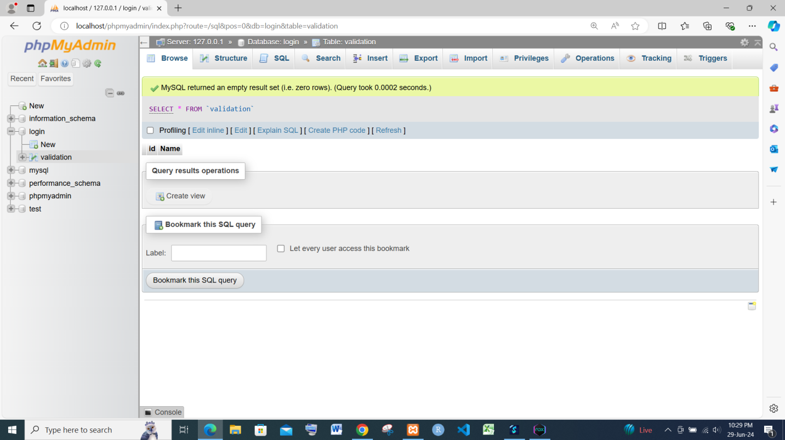

Login SQL

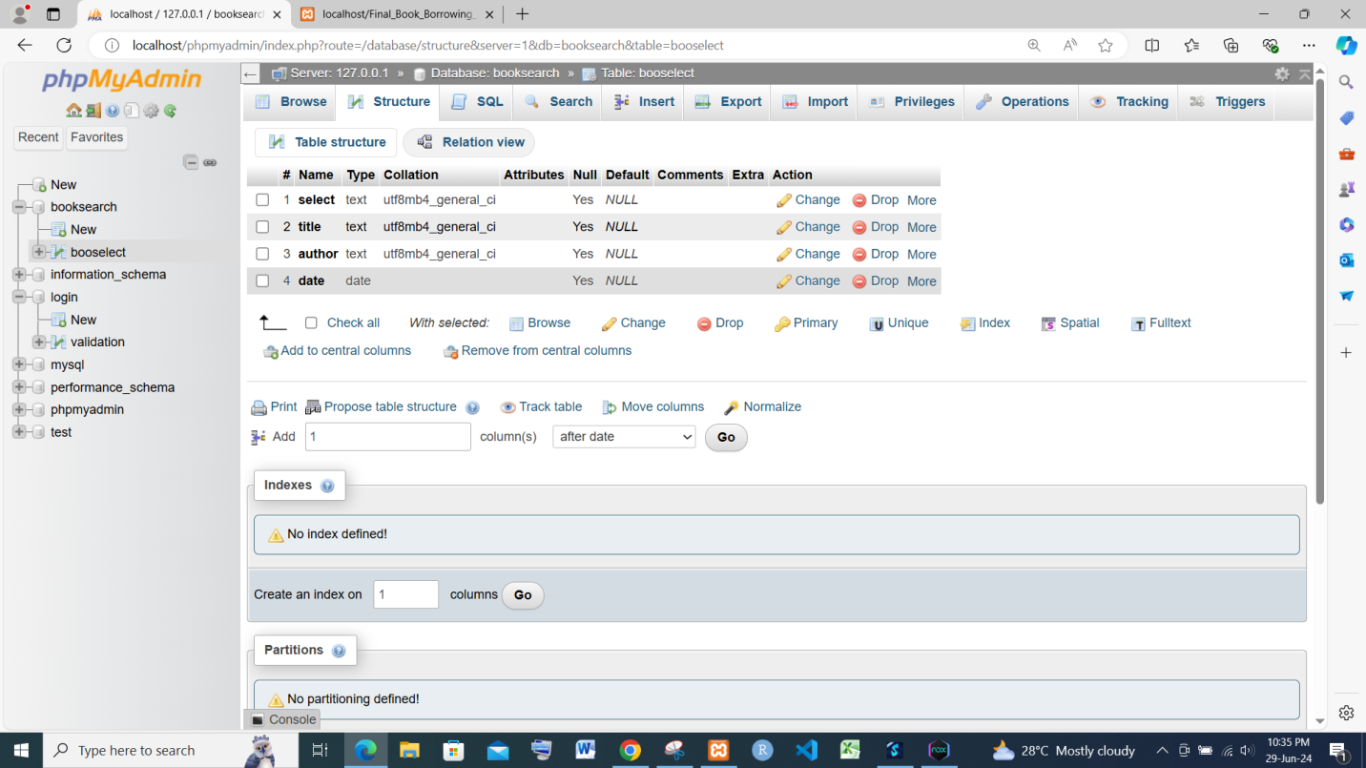

Book Select SQL

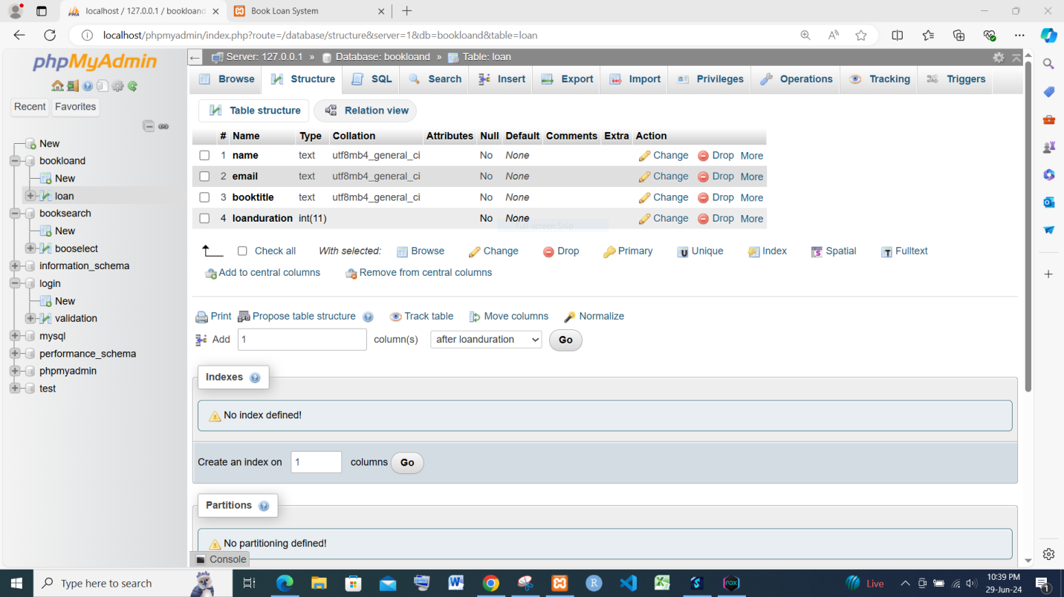

Book Loan SQL

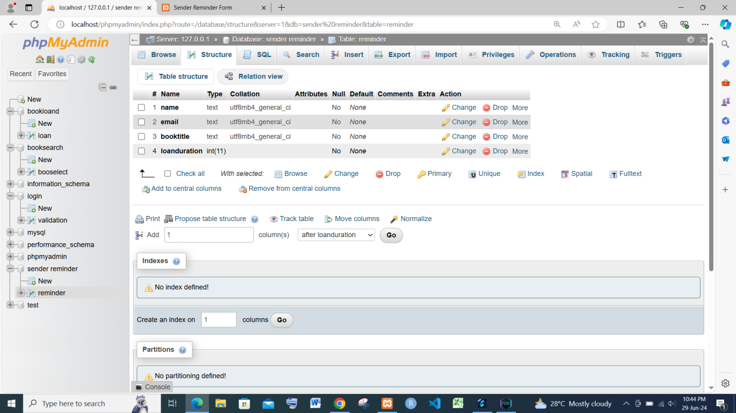

Sender Reminder SQL